Hypercube Quorum Consensus for Mutual Exclusion and Replicated Data Management
A. W. Fu, W. K. Lau, F. K. Ng and M . H. Wong
Computers Math. Applic., Vol. 36, No. 5, 1998, pp. 45-59
Abstract
In this paper we impose a hypercube structure on the copies of data items. A protocol is then developed using the information of the logical structure to manage replicated data with high availability and at the same time minimize the communication cost incurred for some networks. The algorithm for this protocol is given, and properties of the protocol are investigated.
- Introduction
- Model
- Preliminaries
- Generalized HQC
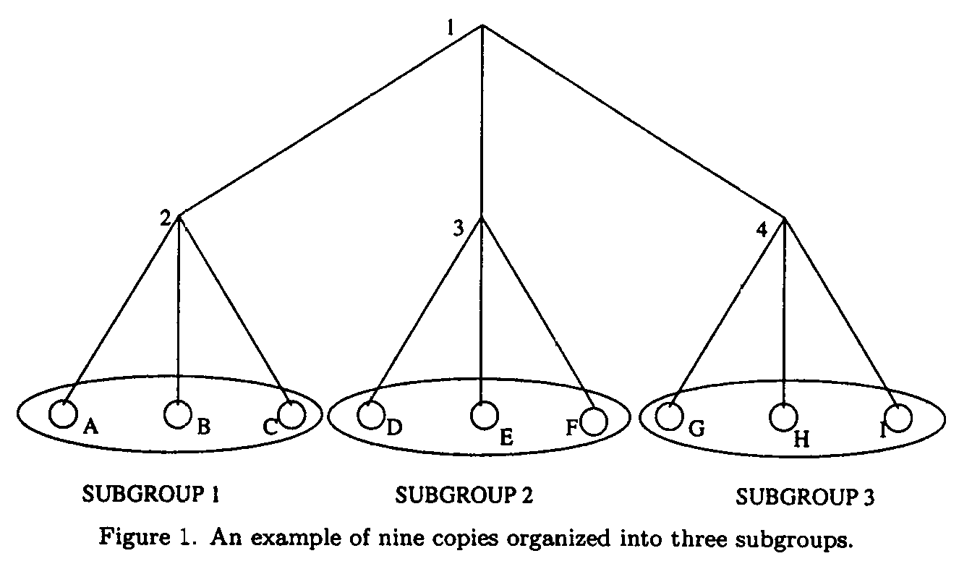
- Hypercube Coterie and WR-Coterie Protocol
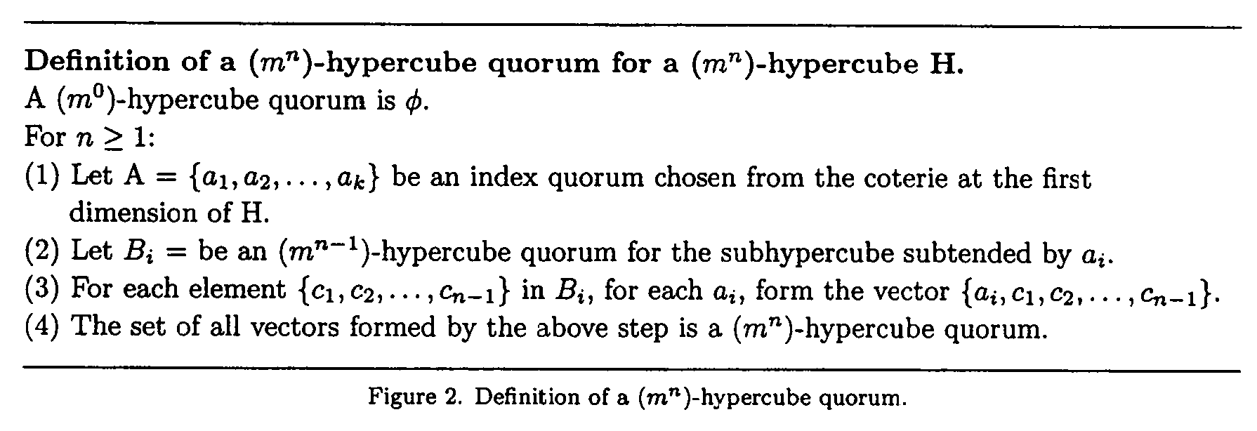
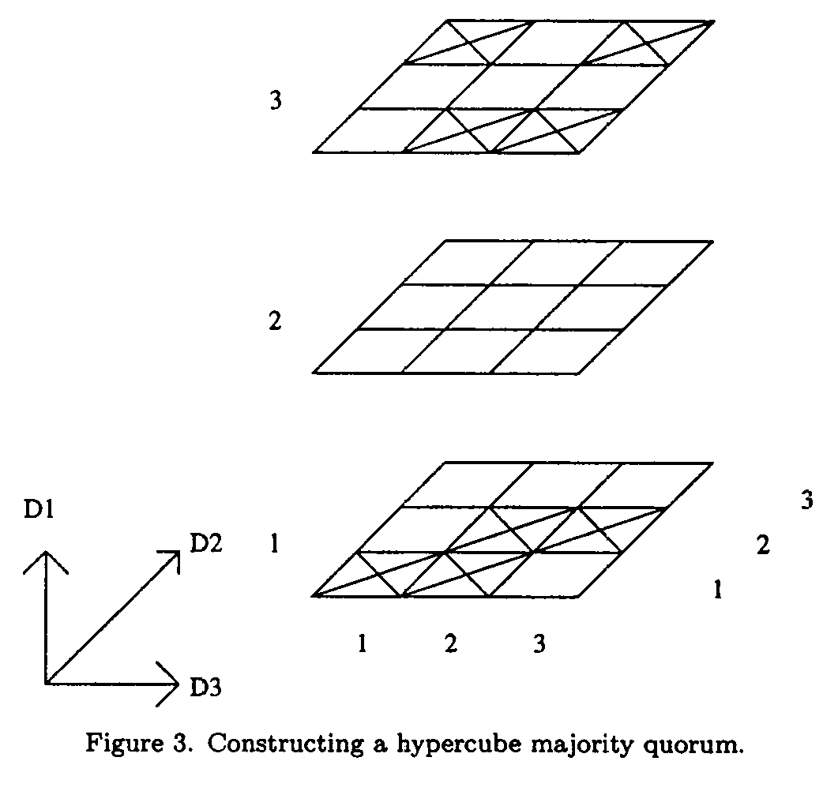

A={a₁,a₂}={1,3}

A={a₁,a₂}={1,2}
B₁={{1},{2}};B₂={{2},{3}}
⇒{{1,1},{1,2},{2,2},{2,3}}

A={a₁,a₂}={1,3}
B₁={{2},{3}};B₂={{1},{3}}
⇒{{1,2},{1,3},{3,1},{3,3}}

{{1,1,1},{1,1,2},{1,2,2},{1,2,3},{3,1,2},{3,1,3},{3,3,1},{3,3,3}}
- Optimal Communication Cost
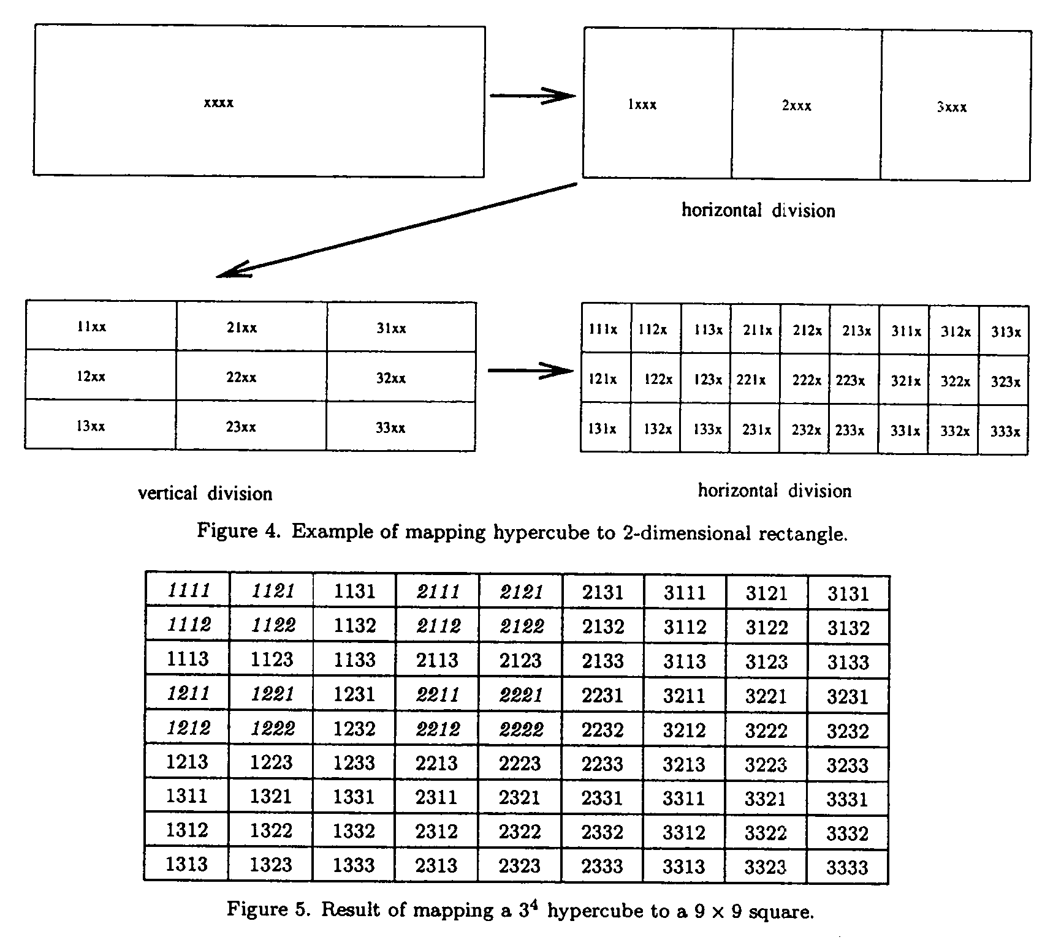
- Quorum Size and Availability Analysis
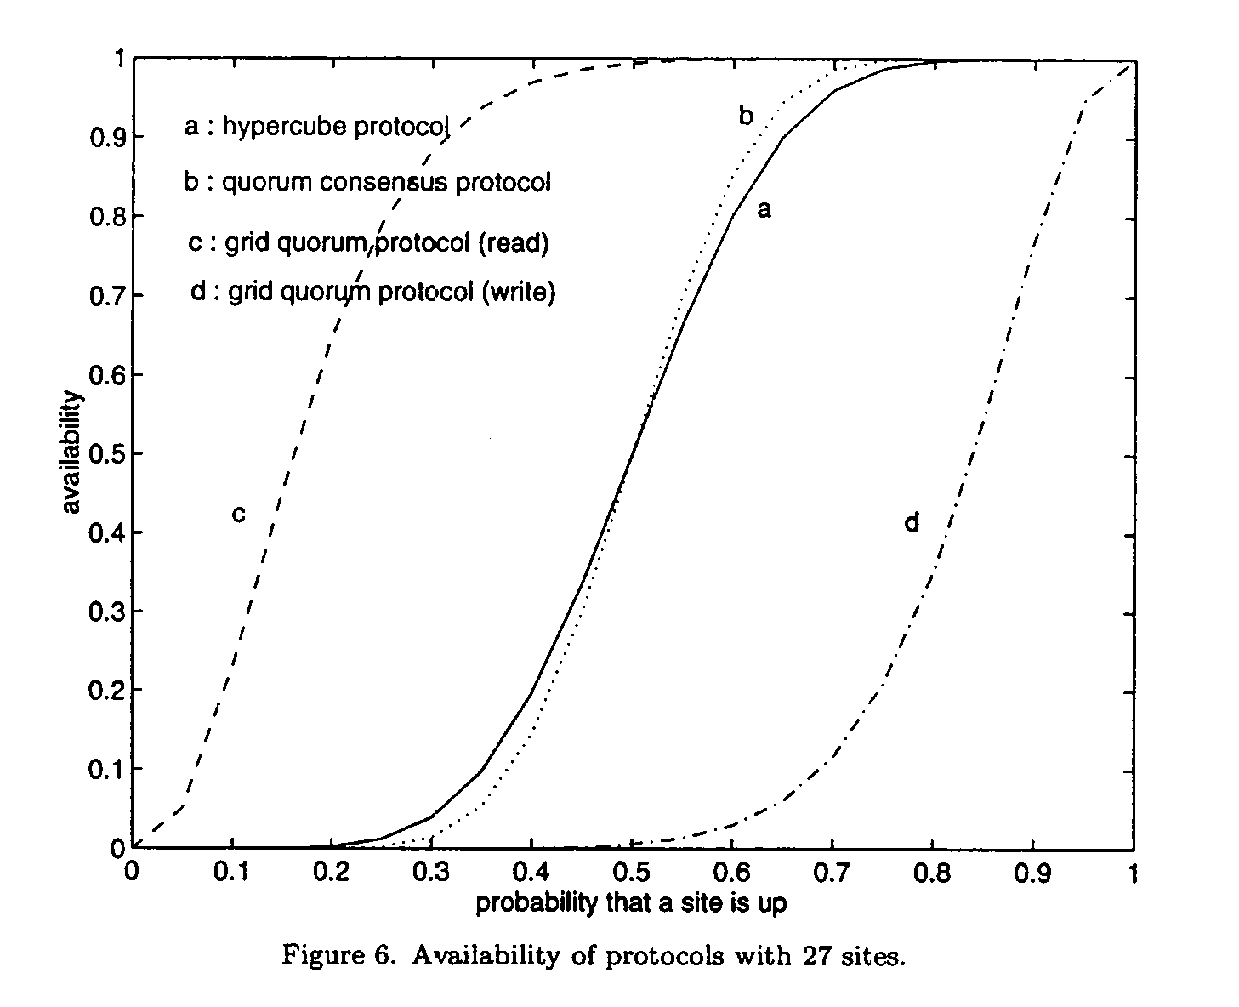 | 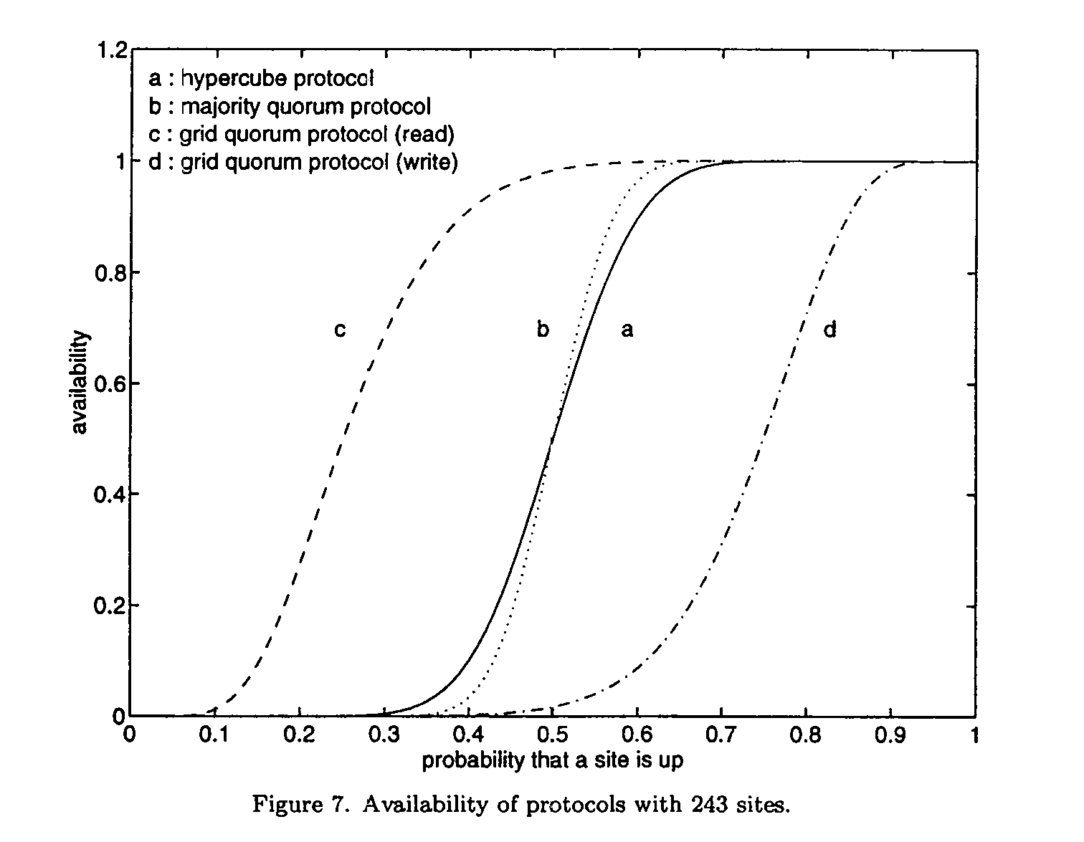
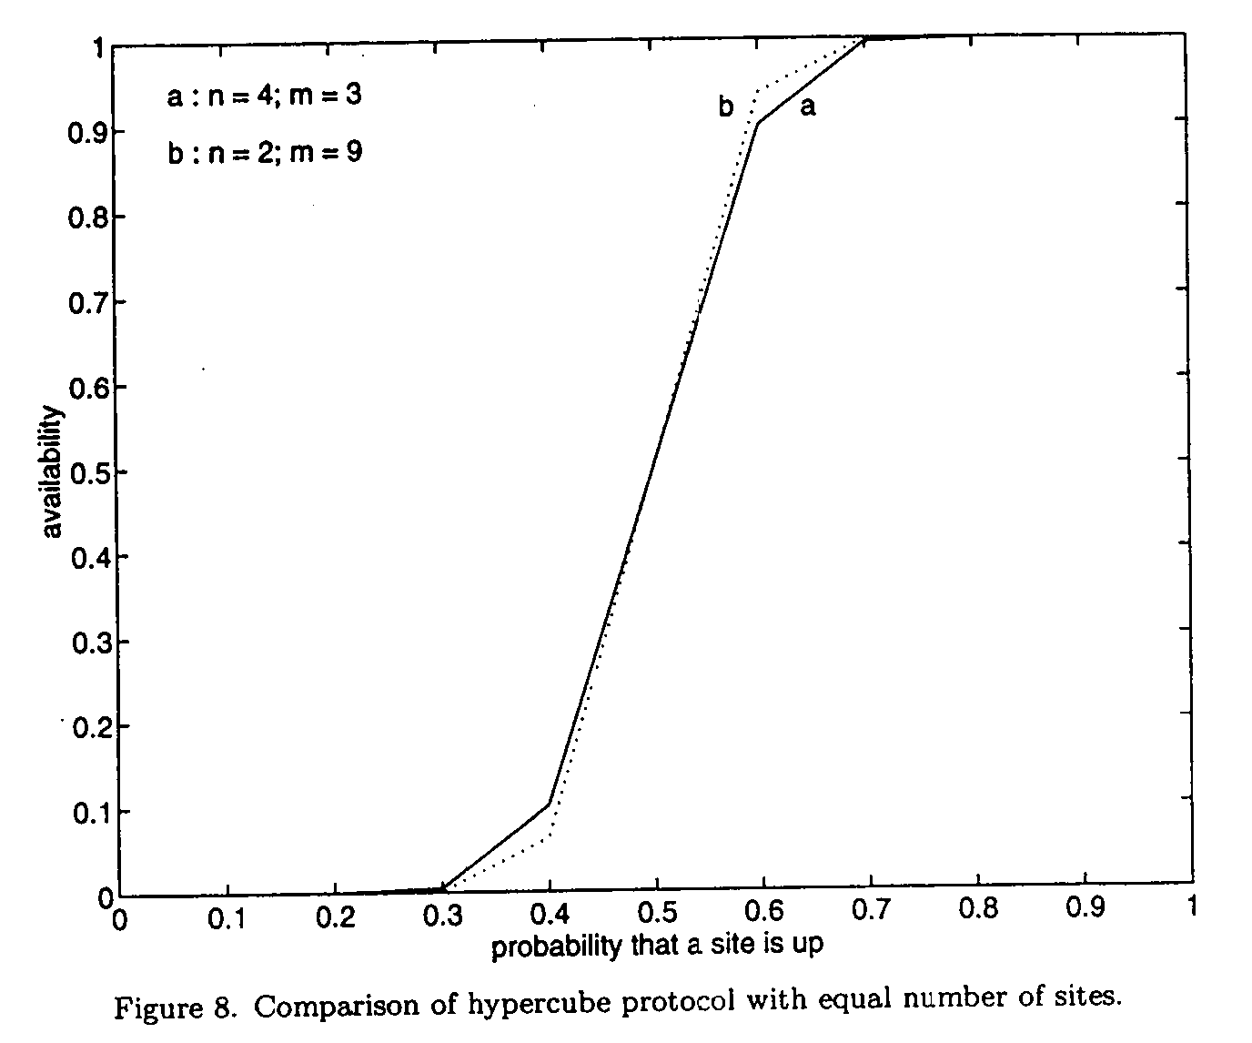 | 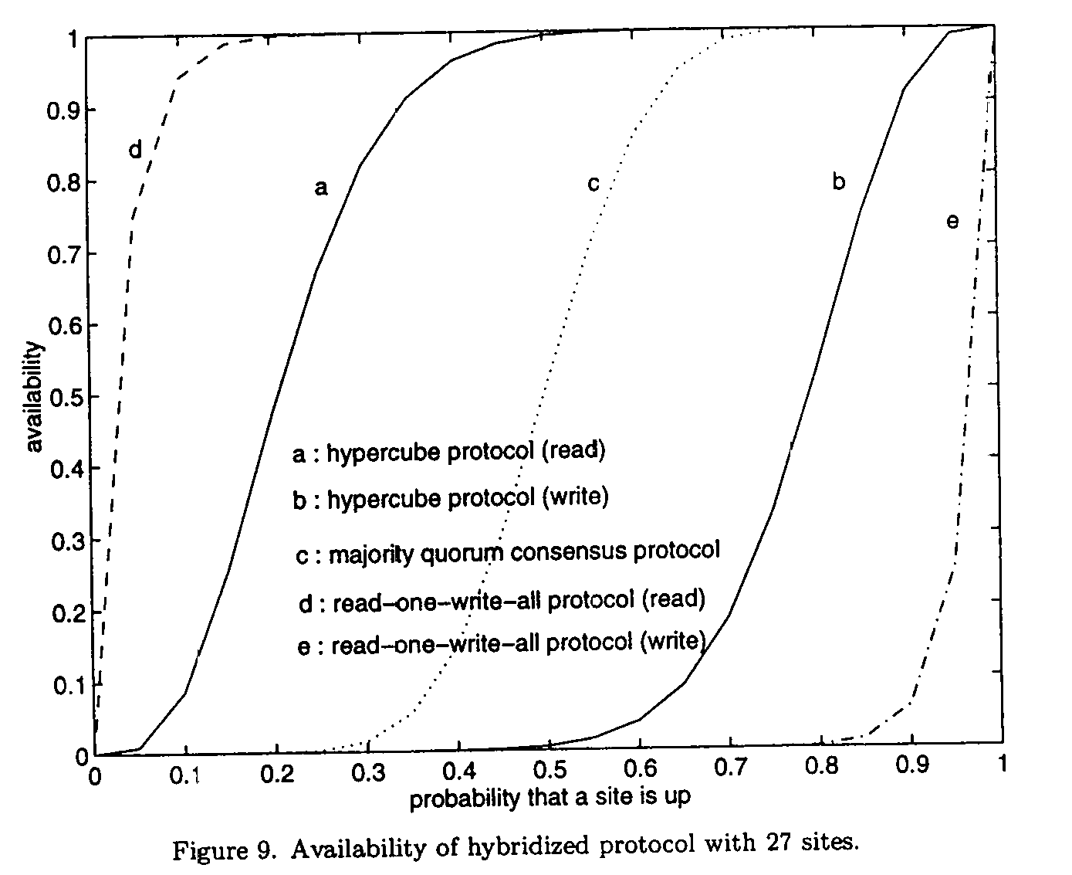

- Hybridization of Protocols
- Conclusion
Created by : Kwo-Tsung Tseng
Date : Dec. 17, 1998

